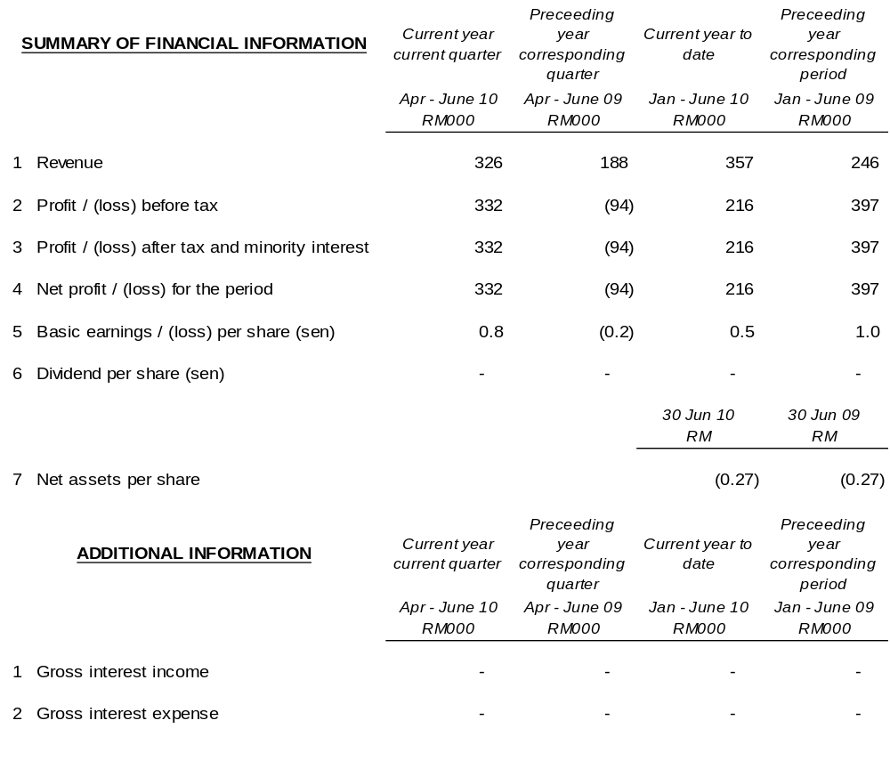

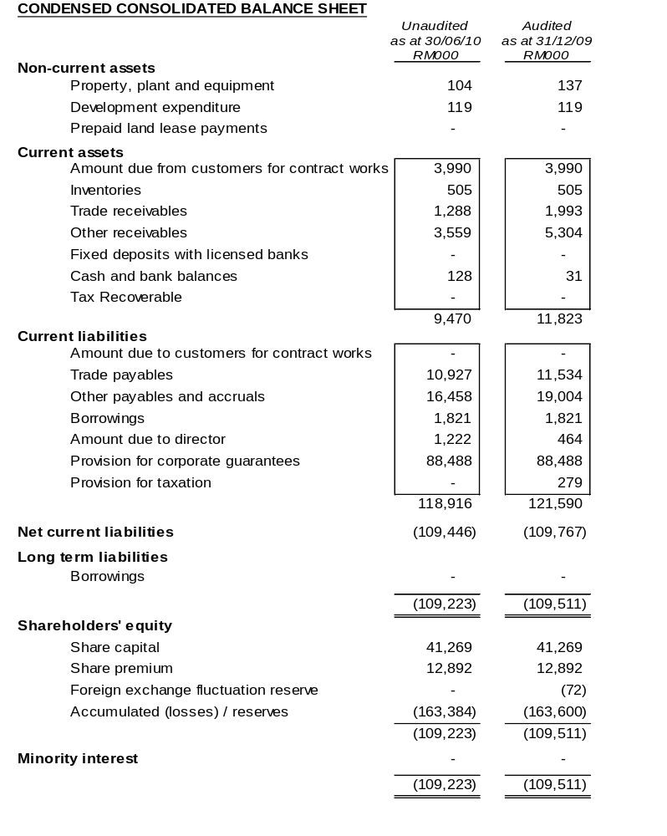

The condensed consolidated balance sheet should be read in conjunction with the Annual Financial Report for the year ended 31 December 2009.

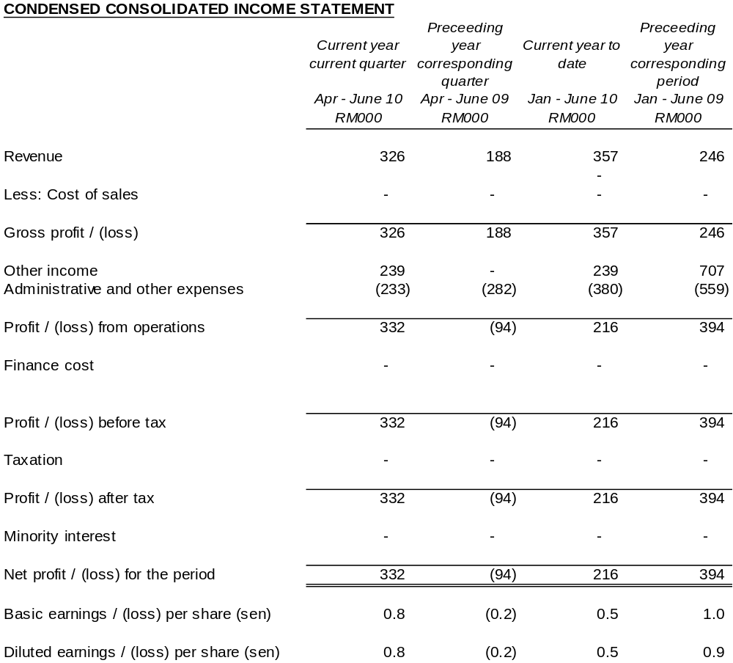

The condensed consolidated income statement should be read in conjunction with the Annual Financial Report for the year ended 31 December 2009.

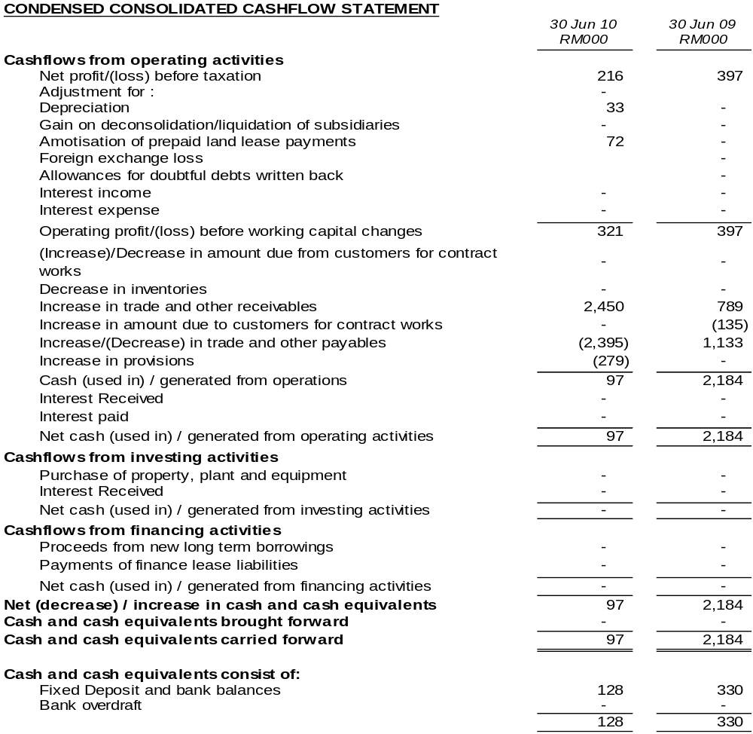

The condensed consolidated cash flow statement should be read in conjunction with the Annual Financial Report for the year ended 31 December 2009.

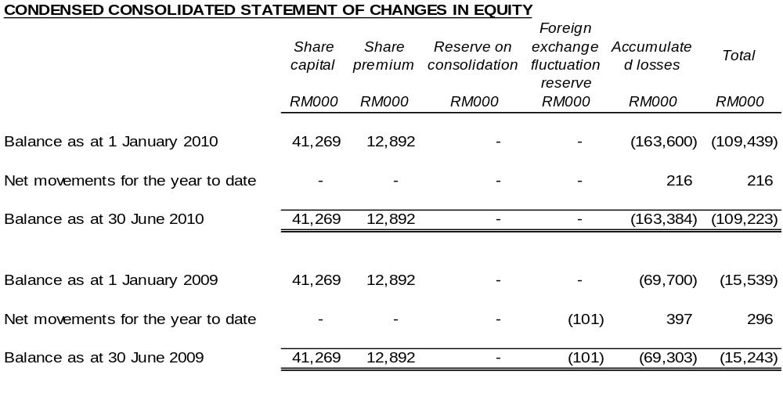

The condensed consolidated statement of changes in equity should be read in conjunction with the Annual Financial Report for the year ended 31 December 2009.

NOTES TO THE INTERIM FINANCIAL STATEMENTS FOR THE PERIOD ENDED 30 JUNE 2010

PART A - EXPLANATORY NOTES PURSUANT TO FINANCIAL REPORTING STANDARDS

(FRS) 134
1. BASIS OF PREPARATION
The interim financial statements are unaudited and have been prepared in accordance with the requirements of Financial Reporting Standard (FRS) 134, Interim Financial Reporting issued by the Malaysian Accounting Standards Board (MASB) and paragraph 9.22 and Appendix 9B of the Listing Requirements of Bursa Malaysia Securities Berhad.
The interim financial statements should be read in conjunction with the audited financial statements of the Group for the year ended 31 December 2008.
2. CHANGE IN ACCOUNTING POLICIES
The accounting policies and methods of computation adopted by the Group in these quarterly financial statements are consistent with those adopted in the most recent annual audited financial statements for the year ended 31 December 2007, except that the Group has adopted the new/revised standards mandatory for annual periods beginning on or after 1 January 2007, as follows:
FRS 117 | Leases
FRS 119₂₀₀₄ (Revised) | Employee Benefits – Actuarial Gains and Losses, Group Plans and Disclosures
FRS 124 | Related Party Disclosures

The adoption of the above FRSs does not have any significant financial impact on the Group.
3. STATUS OF AUDIT QUALIFICATIONS
The annual financial statements of the Group for the year ended 31 December 2009 were qualified.
Details of the Audit Qualification are as follows:-
Basis for Disclaimer of Opinion

(i) Recoverability of the following account balances:

(a) Amount due from contract customer
As stated in Note 16 to the financial statements, the amount due from contract customer of RM4.0 million relates to a project undertaken by the Group with the Selangor local authority for a contract sum of RM9,503,080. The first phase of the project has been completed but now pending approval for payment from the Selangor local authority. There has been no further active development until such time that the Group has regularised its financial position.

(b) Non-trade receivable
As stated in Note 17 to the financial statements, non-trade receivable amounted to RM3.9 million of the Group relates to the same project as mentioned in (a) above. The amount has been outstanding and no payment has been received as at the date of this report even though the Directors are pursuing the matter with the Selangor local authority to recover the outstanding amount.

No impairment losses have been made for the above balances in the financial statements of the Group at this juncture. The Directors are confident that these amounts are recoverable in the future. However, in the absence of any documentary evidence and alternative audit procedures, we were unable to determine the recoverability of the above mentioned balances.

(ii) Unreconcilable differences of trade receivable

Trade receivable amounted to RM1.5 million of the Group had been long outstanding. On 21 July 2009, the said receivable had provided a statement of account stating that the outstanding amount due to the Company is RM2.6 million. However, we are unable to verify certain of the reconciling items as contained in the reconciliation statement provided to us as certain supporting documents are not made available as well as some amounts remained unreconciled. As such, we are unable to ascertain the accuracy of the trade receivable balance as at the end of the financial year.

(iii) Audited financial statements of subsidiary were not made available

The audited financial statements of one of the subsidiaries, Ark Thai Company Limited, were not made available to us. The cost of investment in this subsidiary amounted to RM1.6 million of which an impairment loss of RM1.57 million has been made in the financial statements of the Company. The loss for the financial year of RM0.1 million and the deficit in shareholders’ funds of RM2.3 million of this subsidiary which have been included in the consolidated financial statements of the Group. As the audited financial statements of this subsidiary are not available to us, we are unable to ascertain the possible adjustments, if any, to the consolidated financial statements that might have been necessary should the audited financial statements of the said subsidiary been made available.

Disclaimer Opinion

Because of the significance of the matter as discussed in the Basis for Disclaimer of Opinion paragraph, we do not express an opinion on the financial statements.

Emphasis of Matter

Without further modifying our opinion in the preceding paragraph, we draw attention to note 1(a) to the financial statements which discloses the premise upon which the Group and the Company have prepared their financial statements by applying the going concern assumption. The Company and its subsidiaries had obtained approval from the Securities Commission (“SC”) on the Proposed Corporate Restructuring Exercise (“PCRE”) and the Proposed Debt Restructuring Scheme (“PDRS”) on 30 April 2007. The time frame for implementation of PCRE had expired on 31 December 2009 and no further extension of time has been given by the SC. A new advisor was appointed on 27 April 2010 to deal with, amongst others, the request to the SC for further extension of time to implement the PCRE and as at the date of this report, the Company is still in the midst of preparing the application to be submitted to the SC for further extension of time.

On 31 March 2010, Bursa Securities (“Bursa”) had issued Notice of show cause on de-listing of securities and on the same date, Bursa suspended the trading in the securities of the Company with effect from 2 April 2010, pursuant to paragraph 8.14C(5)(a) of the Listing Requirements, on the ground that the Company has failed to implement its regularisation plan within the time frame and no further extension of time has been given by the SC.

In addition, the Group’s and the Company’s current liabilities exceeded their current assets by RM109.8 million and RM90.4 million respectively. As at the balance sheet date, the Group’s and the Company’s deficit in shareholders’ funds amounted to RM109.5 million and RM90.2 million respectively.

Thus, these factors raise substantial doubt that the Group and the Company will be able to continue as going concerns. The appropriateness of preparing the financial statements of the Group and of the Company to continue as going concern is dependent upon the successful implementation of the PCRE as well as the ability of the Group and the Company to be successful in their future operation and profitability. Accordingly the financial statements of the Group and of the Company do not include any adjustments relating to the amounts and classifications of assets and liabilities that might necessary should the Group and the Company be unable to continue as going concerns.
4. ITEMS OF UNUSUAL NATURE AND AMOUNT

There were no unusual items affecting assets, liabilities, equity, net income or cashflows during the current quarter under review.
5. SEASONAL OR CYCLICAL FACTORS
There are no significant variations to the level of profit due to seasonal or cyclical effects of operations.
6. CHANGES IN ESTIMATES
There were no changes in estimates of amounts that give a material effect for the current quarter.
7. DEBT AND EQUITY SECURITIES
There were no issues of equity securities and repayment of debt securities, share buy-backs, share cancellations, shares held as treasury shares and resale of treasury shares during the current quarter.
- SEGMENTAL INFORMATION
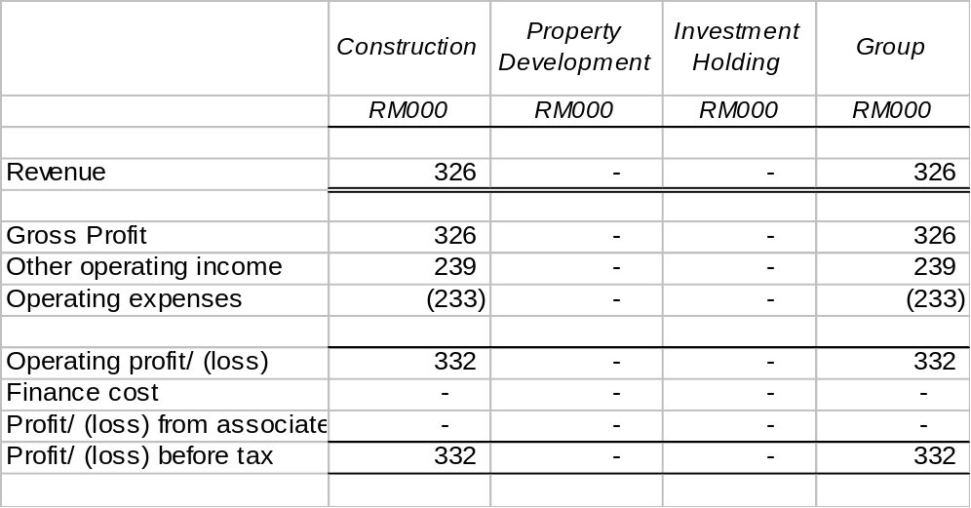
9. REVALUATION OF PROPERTY AND EQUIPMENT
The valuations of property and equipment have been brought forward without amendment from the financial year ended 31 December 2009.
10. CONTIGENT LIABILITIES AND CONTIGENT ASSETS
All Corporate Guarantees given by the Company in respect of credit facilities and certain creditors of Lankhorst Pancabumi Contractors Sdn Bhd (in liquidation) has been included in the accounts and will be addressed by the Company pursuant to the PCRE.
11. CHANGES IN GROUP COMPOSITION
There were no changes to the Group’s composition during the quarter under review.
12. SIGNIFICANT SUBSEQUENT EVENTS
There were no significant events subsequent to the end of the current quarter up to the date of this report that have not been reflected in the financial statements for the current quarter under review.
13. CAPITAL COMMITMENT
The Group has no capital commitment as of 30 June 2010.

PART B - EXPLANATORY NOTES PURSUANT TO APPENDIX 9B OF THE LISTING REQUIREMENTS OF BURSA MALAYSIA SECURITIES BERHAD
14. REVIEW OF PERFORMANCE
The Group recorded a profit before tax of RM0.33 million in the current quarter as compared to a loss before tax of RM0.1 million in the same quarter of the preceding year. The profit recorded was mainly due to recoveries and reversal of provisions for doubtful debts made during previous periods.
15. EXPLANATORY NOTE ON MATERIAL CHANGE
There has been no material change during the current quarter.
16. PROSPECTS
The Group faces more challenges in an unstable operating environment in 2010. During this crucial period, Ark Group will persevere for an improved performance for 2010.
In addition, the Company will continue with its ongoing efforts to implement the PCRE and improve operational efficiency in order to achieve better results.
It must be reiterated that the implementation of the PCRE is crucial to moving forward. Once this phase is completed, the Group can then implement its many measures to build on its order book concentrating initially mainly on local projects and proceeding with new launches at our development project in Kuala Kubu Bahru, Selangor (“KKB”). The Group is also exploring smart partnerships with land owners to leverage and take advantage of a pick up in the industry expected in the not too distant future.
17. EXPLANATORY NOTE ON PROFIT FORECAST/GUARANTEE
No profit forecast / guarantee have been given by the company.
18. TAXATION
Taxation for the current period is as follows:
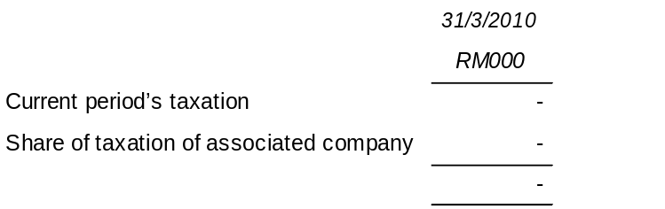
No taxation has been provided in the current year to date.
19. UNQUOTED INVESTMENTS / PROPERTIES

There has been no disposal of any unquoted securities or properties during the current quarter.
20. QUOTED SECURITIES

There has been no purchase or disposal of any quoted securities during the current quarter.
21. CORPORATE PROPOSALS
The Company had on 23 January 2007 submitted to the Securities Commission (“SC”) its Proposed Corporate Restructuring Exercise (“PCRE”) entailing the following:-
Proposed Capital Reduction;
Proposed Acquisitions;
Proposed Debt Restructuring;
Proposed Liquidation;
Proposed Rights Issue with Warrants; and
Proposed Placement with Warrants
The SC had vide their letter dated 30 April 2007 approved the aforementioned PCRE. In this regard, the Company has commenced the implementation process of the abovementioned PCRE via liquidating its subsidiaries that was not part of the Group moving forward.
In addition, the Company and its affected subsidiaries have also obtained the required majority pursuant to Section 176 of the Companies Act 1965 at their earlier held respective Court Convened Meetings (“CCM”). These CCM were held in line with the Proposed Debt Restructuring Scheme (“PDRS”) which forms part of the said PCRE.
Pursuant to the CCM and Extraordinary General Meeting (“EGM”) of the Company that were held on 28 February 2008, the shareholders of the Company had approved the PDRS and PCRE during the CCM and EGM respectively. The above meetings were conducted in line with the PCRE which was approved by the SC on 30 April 2007.
On 7 April 2008, the Company obtained an order from the High Court of Malaya (“Court Order”) sanctioning the said PCRE pursuant to Section 176 (3) of the Companies Act 1965. In the same Court Order, the High Court of Malaya also confirmed the Proposed Capital Reduction which forms part of the aforementioned PCRE.
Notwithstanding the above, pursuant to Chapter 18 of the SC’s guidelines on Issue/Offer of Securities (being the guidelines under which the PCRE was approved), the PCRE is to be implemented within twelve (12) months from the first approval date of 30 April 2007, i.e. 30 April 2008. The Company’s adviser, Maybank Investment Bank (“Maybank IB”) had on a number of occasions sought the SC’s approval for an extension of time and in this regard, the SC has given the Company up to 31 December 2009 to implement the PCRE.
On 25 June 2010, the SC approved a further extension of time for the company to implement the PCRE up to 31 December 2010.
22. OFF-BALANCE SHEET FINANCIAL INSTRUMENTS
There are no off-balance sheet financial instruments in issue.
23. CHANGES IN MATERIAL LITIGATION
There were no changes in material litigation involving the remaining companies within the Group during the quarter under review.
24. DIVIDEND
No interim or final dividend has been declared or recommended.

25. AUTHORISATION
This interim financial report for the financial period ended 30 June 2010 has been seen and approved by the Board of Directors of ARK Resources Berhad on 25 August 2010 for release to Bursa Securities.

